Chapter 10 The nature of waves

Chapter test Total marks 53

Name: ______________________________ Class: ____________ Date: _________

Section A (1 mark per question)

Question 1

A drummer beats his drum 8 times every 3.00 s. What is the frequency of the drumming?

A 0.67 Hz

B 2.70 Hz

C 1.67 Hz

D 3.00 Hz

Question 2

According to wave theory, what happens when two crests meet?

A They pass through each other with no visible effect.

B They cancel out each other, leaving an area of no disturbance.

C They superimpose upon one another to momentarily create a new waveform.

D They reflect as if each has collided with a solid wall.

Question 3

Sound with a wavelength of 2 cm is travelling at 340 m s–1 in air. What is its frequency?

A 34 000 Hz

B 17 000 Hz

C 170 Hz

D 340 Hz

Question 4

Which of the following do all waves transfer from one point to another?

A matter and information

B energy and matter

C energy

D information and energy

Question 5

What is the name given to the point of maximum negative displacement along a transverse wave?

A rarefaction

B compression

C trough

D crest

Section B

Question 6

Explain the difference between a longitudinal wave and a transverse wave, and give an   
example of each. (4 marks)

Question 7

**a** Sketch a displacement versus distance graph representing the movement of particles with the following properties: wavelength = 0.2 m, amplitude = 0.05 m. (2 marks)

**b** Use a dot to indicate the location of the particle on the graph at a distance of 0.2 m from the origin. Assume the wave is travelling to the right and use an arrow to indicate the direction (up or down) this particle is moving at the time shown. (1 mark)

Question 8

Venus is significantly hotter than the Earth, partly because it is closer to the Sun and partly because of the ‘run-away greenhouse effect’. Venus’s average distance from the Sun is 108 million km and the Earth’s average distance from the Sun is 150 million km. If the Earth receives approximately 1370 W m–2 of energy from the Sun, how much does Venus receive? (2 marks)

Question 9

With reference to waves, define the term ‘destructive interference’. Use an example to support your definition. (2 marks)

Question 10

a Determine the period of the wave responsible for the motion of the particle shown in the graph below. (1 mark)



b Calculate the speed of the wave, if the wave moves 4 m during one period. (1 mark)

Question 11

Explain why, using your knowledge of sound waves, you can hear an echo when you shout across a deep river valley. (2 marks)

Question 12

A wave was observed crossing the boundary between two mediums at an angle. The wave travelled the same distance in each medium but took more time to travel this distance in the second medium compared to the first.

Compare the properties of the wave before and after it crossed the boundary between the two mediums. (2 marks)

Question 13

Outline the conditions that must be met for a standing wave to be produced in a string fixed at both ends. (4 marks)

Question 14

Two pulses on a string approach each other as shown in the diagram below.



**a** On the grid below, draw the positions of the two individual pulses 2 s after their positions shown in the diagram above. (2 marks)

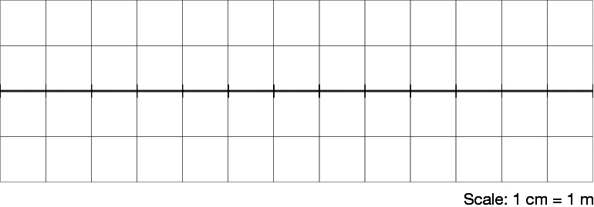

b On the same grid, in another colour, draw the superposition of the two pulses at this time. (1 mark)

Question 15

A guitar player holds a string stationary at a point along the neck of the guitar by pressing her finger on it. Her finger is 0.6 m from the fixed end of the string and the string is plucked somewhere along this 0.6 m.

**a** Describe where the nodes and antinodes of the first harmonic exist on this 0.6 m   
of string. (1 mark)

**b** Calculate the wavelength of the first harmonic standing wave produced in the string. (1 mark)

**c** The player increases the length of the string to 0.7 m. Calculate the frequency of the third harmonic if the speed of the wave is 12 m s–1. (2 marks)

Question 16

A simulator of the human head is used to determine the efficiency of hearing aids. The process involves a set-frequency sound being produced from a speaker at one side of the simulator as shown in the diagram. Hearing aid A is closest to the speaker and a display of its reception is given in the graph below.

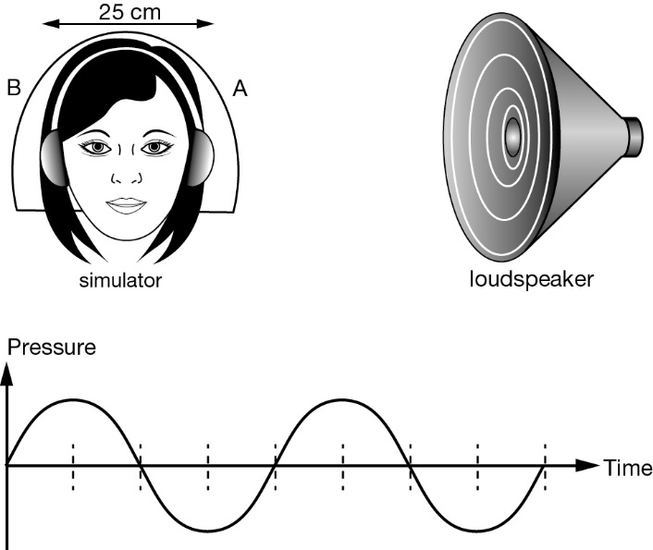

**a** On the same axes draw the display as it would appear one-quarter of a cycle later. (2 marks)

Hearing aid B is 25 cm further from the speaker than hearing aid A. The graph below indicates the reception from both hearing aids at the same time.

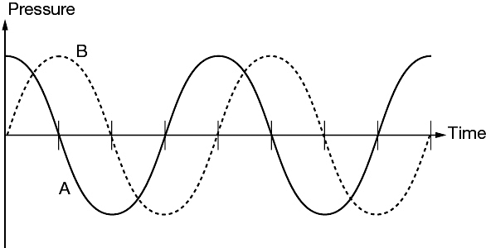

**b** What is the wavelength of the sound? (2 marks)

**c** Given the speed of sound is 340 m s–1, determine the frequency of the sound. (2 marks)

Question 17

A student used an app on their phone to produce sound of varying frequency in two different pipes. The student started from 20 Hz and increased the frequency.

In pipe 1 resonances were first observed at 600 Hz, then1800 Hz, 3000 Hz and 4200 Hz.

In pipe 2 resonances were first observed at 800 Hz, then 1600 Hz, 2400 Hz and 3200 Hz.

For each pipe, identify by using calculations which is the open pipe and which is the pipe closed at one end *(2 marks)*.

For each end of each pipe, state whether there is a node or antinode in pressure *(1 mark)*.

For the fundamental frequency, state the fraction of a wavelength present *(1 mark)*.

a Pipe 1: (4 marks)

b Pipe 2: (4 marks)

c For a 6 m pipe closed at one end, calculate the wavelength of the third harmonic assuming the speed of sound is 340 m s–1. (2 marks)

d A speaker of unknown frequency is sending sound down a pipe. A microphone measures a maximum in sound pressure every 7 cm. Calculate the frequency of sound if the speed of sound is 340 m s–1. (2 marks)

Question 18

A dolphin produces echolocation clicks between 40 and 130 kHz. Show by calculation the smallest object a dolphin can locate assuming the speed of sound in water is 1500 m s–1. Explain why this limit occurs. (2 marks)